MUSA5000

Assignment #2: OLS, Spatial Lag, Spatial Error, and Geographically Weighted Regressions

Akira Di Sandro, Sofia Fasullo, Amy Solano

Figures from GeoDa

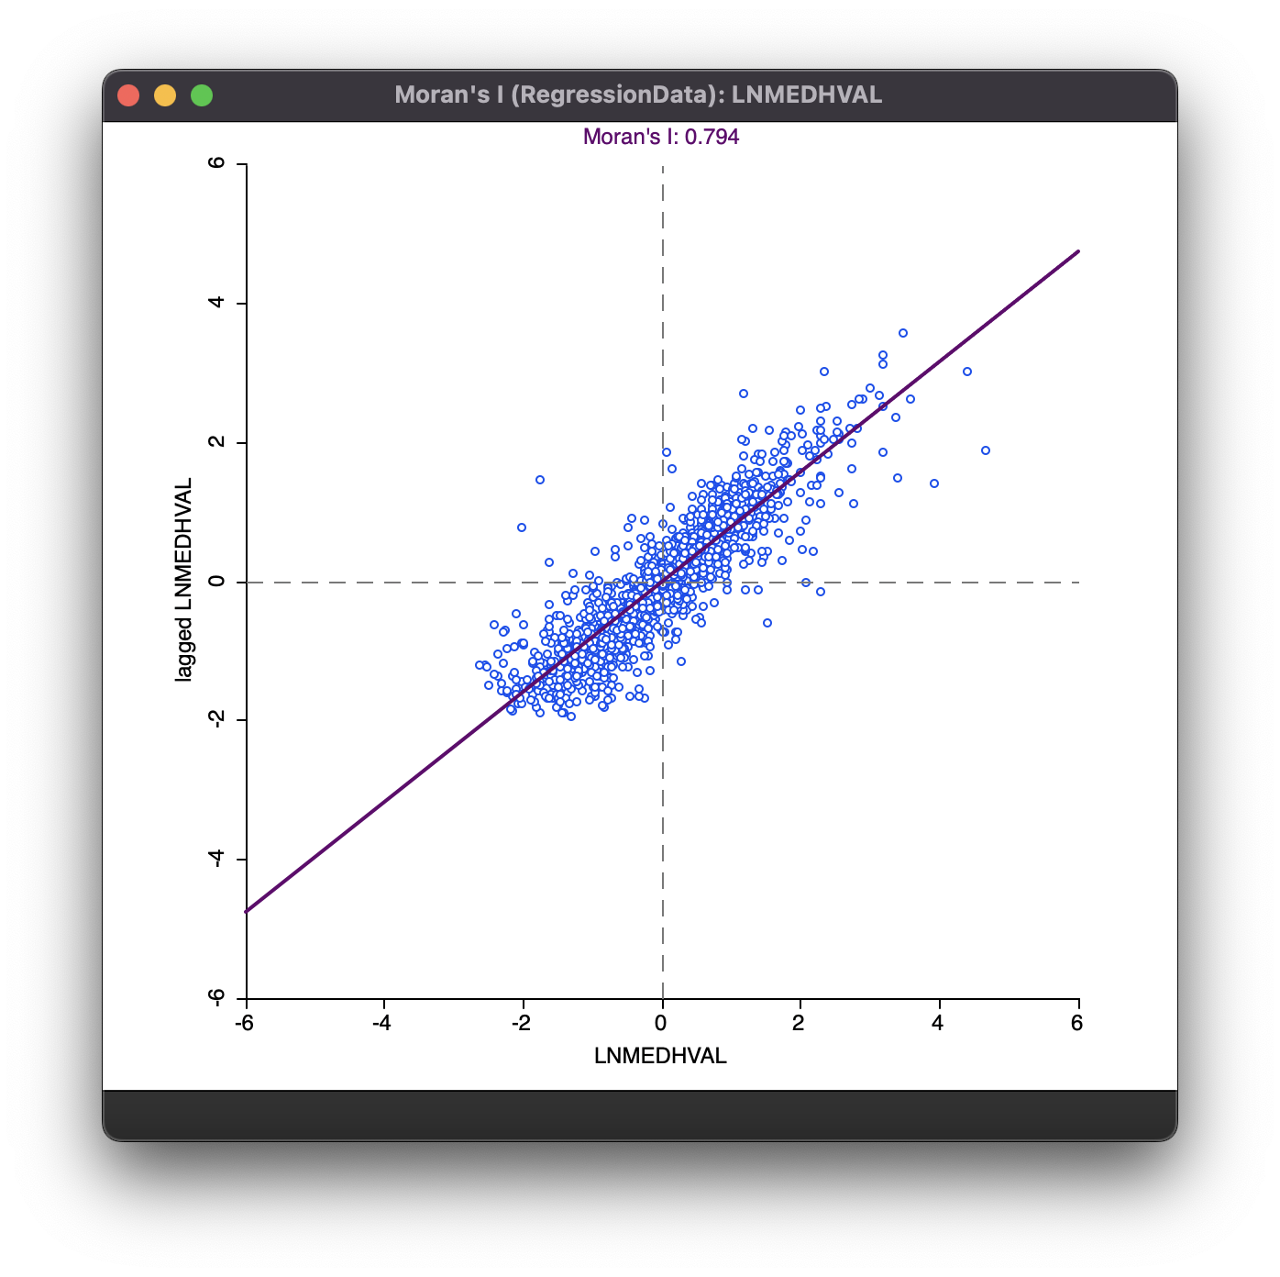

Scatter plot of Global Moran’s I of Median House Value (log-transformed; LNMEDHVAL)

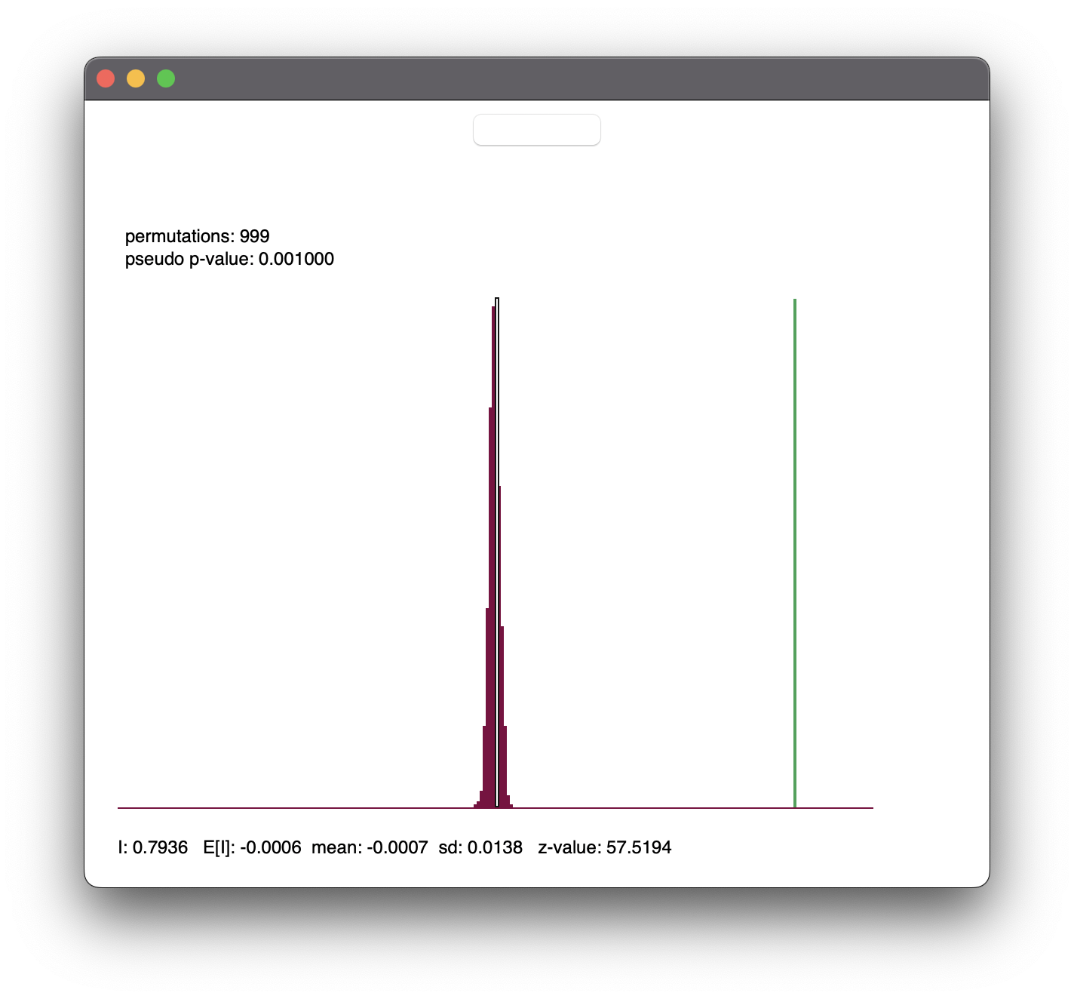

Random Permutations Test for Global Moran’s I of Median House Value (log-transformed; LNMEDHVAL)

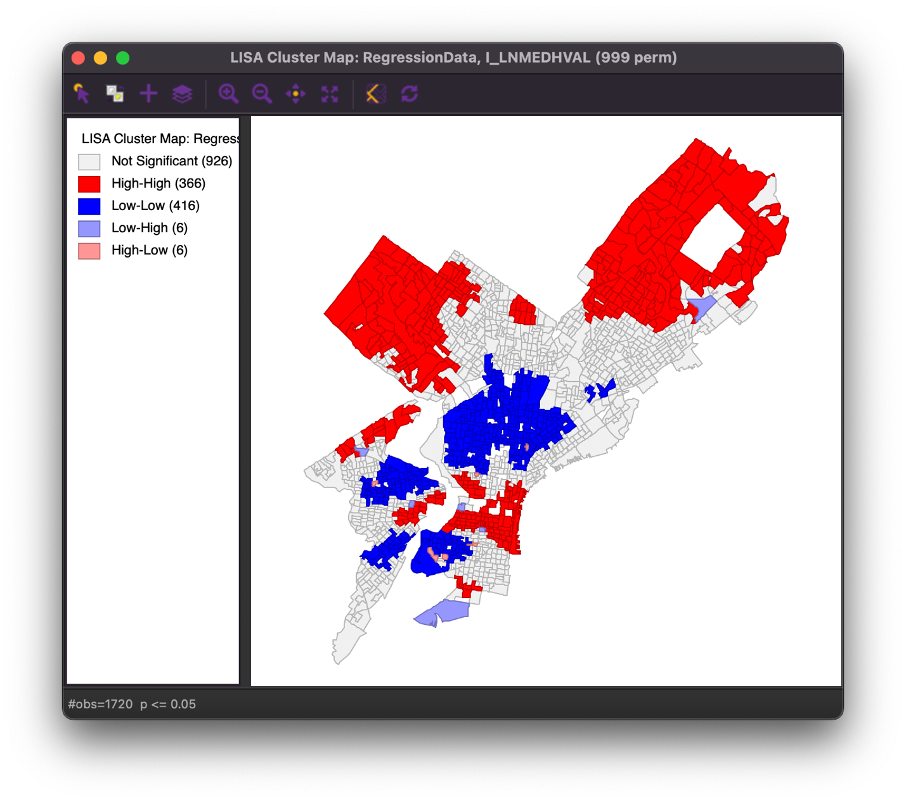

Local Moran’s I results for Median House Value (log-transformed; LNMEDHVAL)

Cluster Map

Local Moran’s I results for Median House Value (log-transformed; LNMEDHVAL)

Significance Map

Scatter plot of OLS_RESIDU and WT_RESIDU

Scatter plot of Global Moran’s I of OLS_RESIDU

Random Permutations Test for Global Moran’s I of OLS_RESIDU

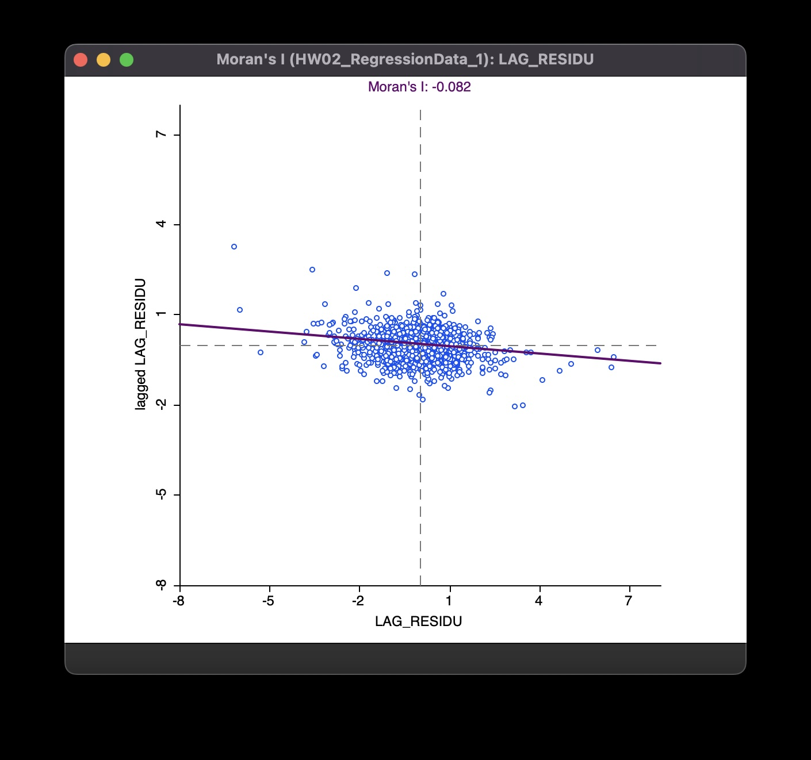

Scatter plot of Global Moran’s I of LAG_RESIDU

Random Permutations Test of Global Moran’s I of LAG_RESIDU

Scatter Plot of Global Moran’s I of ERR_RESIDU

Random Permutations Test of Global Moran’s I of ERR_RESIDU

Scatter Plot of Global Moran’s I of GWR_RESIDU

Random Permutations Test of Global Moran’s I of GWR_RESIDU